Ideation Phase
Define the Problem Statements

Date | January 2026
Team ID | LTVIP2026TMIDS47701
Project Name | Visualization tool for Electric Vehicle Charge and Range Analysis.
Maximum Marks | 2 Marks

Customer Problem Statement Template:
Create a problem statement to understand your customer's point of view. The Customer Problem Statement template helps you focus on what matters to create experiences people will love. A well-articulated customer problem statement allows you and your team to find the ideal solution for the challenges your customers face.


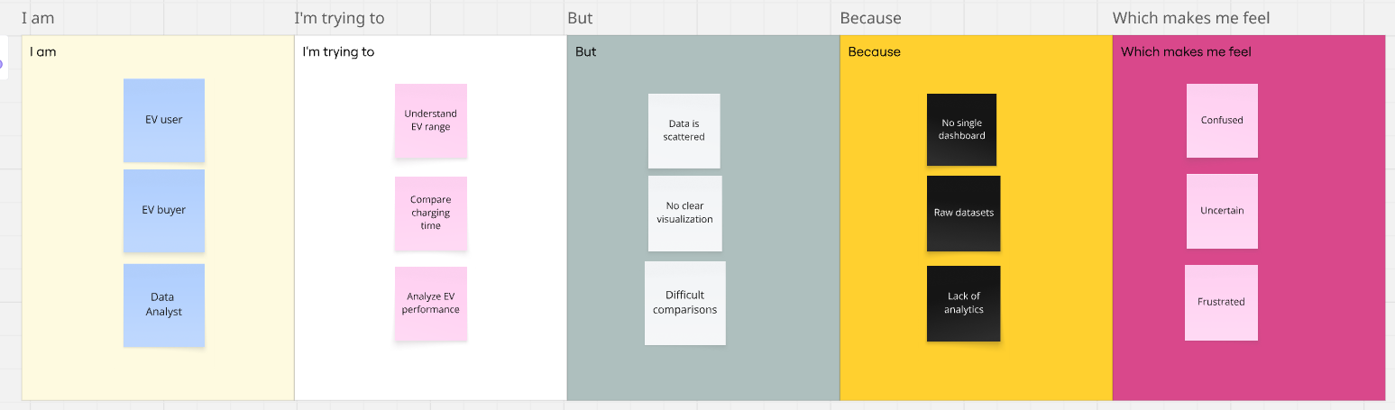
Problem Statement (PS) | I am (Customer) | I’m trying to | But | Because | Which makes me feel
PS-1 | An electric vehicle user. | understand the driving range and charging behavior of different electric vehicles. | understand the driving range and charging behavior of different electric vehicles. | there is no single interactive platform that visualizes EV range and charging data clearly. | confused and uncertain while making decisions.
PS-2 | an EV analyst / policy maker. | analyze EV adoption trends, charging infrastructure, and performance metrics. | existing reports lack clear visual insights and comparisons. | raw data is not converted into meaningful dashboards. | inefficient and limited in data-driven planning.

